The Savage Isles, and of the Repulse of the Ice
By
A scribe of the Assembly

Being a short treatise on the history of the great Invasions, the Landsmen Alliance, and the scourging of the Middle Isles.

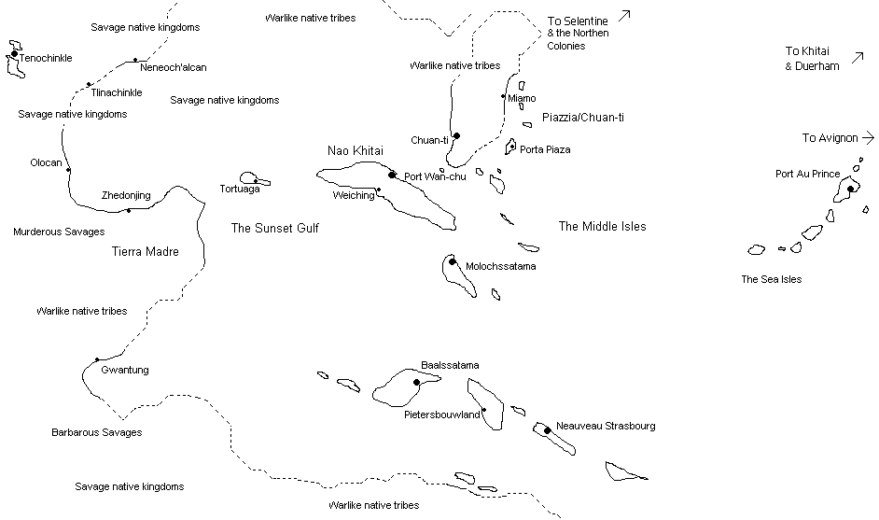

Above, ye map of the Sunset Lands, showing ye principle areas of interest

They came in three great, crashing waves each a generation apart. A tumult of sea peoples, seeking to wash away our lands and people in a tide of blood, driven on by the Hidden Ones and their Ice worship.

But three times the wave crested, and was broken on our arms and magic and ships. A great Alliance was created, drawing together all the nations and peoples under the Roof. Only a threat of such proportions could have drawn our bickering leaders to one banner.

Under the Khitain eunuch Mao Zhedong, the foremost admiral of the age, we were on a holy crusade. Commune and Monarchists put aside their differences, Duergar Progressives stood in line with Syndics. Remnant Alfar, driven by the fall of their race to the Ice spared no effort to redeem their brothers lost honour. Selentinian money paid for Khitain guns and pikes to arm Orcish mercenaries. Ships were built, warded with powerful incantations to prevent the magic’s of the enemy from breaking them, armed with the new cannon and crewed by men of every race.

The walls of the Heavenly City repulsed their armies, whilst the Sea Islanders broke their fleets. Their brute savagery was no match for Khitain guns, Orcish élan or Commune discipline. When the third storm had been weathered we had assembled a mighty fleet, it’s sailors and warriors hardened by the previous fights, a thirst for vengeance burning in the eyes of it’s wizards and priests.

Then, we followed them back across the trackless ocean, the great War Junks carving a path through the seemingly endless waves whilst the smaller caravels and cogs ploughed steadily besides them. When we reached the Islands after many weeks sail, they seemed a paradise to us, heavenly green jewels on an azure bed. There was nothing heavenly about the welcome we received.

They fought us again then, with a violence surpassing even their previous attacks. The butchery was great – men, women and children threw themselves on our blades, or died in a hail of shot, or were rent by the lightning bolts and firestorms our sorcerers threw amongst them. Sleek long boats and great war canoes battered themselves into flotsam against the mighty floating fortresses of the seven great junks, whilst our cannon rent the walls of their citadels and strongholds.

For eleven long years we fought and they died. Many Landsmen too were lost, as were two of the great junks and countless smaller craft. But we had right on our side, and a hatred of the Ice, that it could corrupt a people in such a bountiful place. Plus, we desired their riches, the gold, the silver, the woods and the endless exotic foods and goods these islands produced.

So, eventually, we won. Tortuga was given to the Alfar, those sorry remnants of a once great race that had lost all save their honour in the struggle against the Ice. With their leading position in the Alliance, the Khitains carved out a new empire to replace the lands they had lost to rebellion back in Fu-An. The great Alliance began to split into factions. A squabble for the riches of the Middle Isles began, even as conflict erupted further west.

Khitain explorers and scouts had made contact with the peoples of the Sunset Lands, those great continents to the north- and south-west of what we now called the Middle Isles. Still partly held by the Ice worshipping Ekwesh, they had helped the natives to throw off their overlords and establish their own kingdoms. When more Khitains arrived to claim their lands in the name of the Heavenly Emperor, they fought. Over extended, and with the Alliance dissolving in their rear the Khitains had to pull back.

Meanwhile, their distraction let us lay easy claim to the riches of the Middle Isles. Many of the northern islands were seized by expeditions from the various Selentinian mercantile cities, and the area renamed Piazza after their conqueror, Juan De Garcia el Piazz. With its nearness to their main base of Nao Khitai (and within easy range of the war junks based there!), the Khitains easily held Chuan-tei on western side of the archipelago.

Although numerous fleets (both official and more piratical) have tried to seize or pillage Nao Khitai due to its wealth and strategic position in the centre of the passage through the Middle Isles to the Sunset Gulf and the lands beyond, the Khitains have repulsed all comers. Their war junks are the greatest ships afloat, and the discipline, training and courage of the Heavenly Army is more than a match for any ragtag invasion of buccaneers and adventurers.

The Duergar Progressives seized the fertile isle of Molochssatama, whilst their Loyalist brethren took the rocky fortress isle of Baalssatama. Even now, their manufactories churn out everything from spades to guns.

Further to the south east of the Moloch island chain lie the islands of Pietersbouwland and Nouveau Strasbourg. Seized by various factions of the Cor, they act in uneasy concert to develop (some would say pillage) the rich and fertile lands here, as well as explore the unknown depths of the southern continent.

Meanwhile, the powerful and barbarous native tribes of the western lands build great war canoes and war against any and all for slaves to sacrifice on their stone alters.

In the west, the Tenochlican grow ever more aggressive and sure of their power, subjugating and holding thrall over a growing empire. Their native deserts are now blood soaked and trod by marching armies, whilst their stone cities ring to the screams of the dying as gold ornamented priests and feather cloaked warriors war against any and all for slaves to sacrifice on their stone alters.

The Ininka in the south are little known to us, save for the mighty warriors and savage priests who hold the passes from the coast, barring us from their riches of gold, chocolate and knowledge. They believe themselves safe in their high mountain fastness, but their richness tempts many to try an expedition to the south.

In the north and west, and in the isthmus dividing these empires, and even amongst the islands we call our own fastnesses, savage native tribes hunt their enemies whooping through the jungles, swamps and river valleys, to take their heads, and therefore their power. Amongst the calls of exotic animals and birds, and amidst a bounty of plants so rich as to defy believe they do commit slaughter and murder according to their ancient ways.

In the Tierra Madre lurk the remnants of the abandoned Ekwesh cities, the centre of their sorcerous practises and last haven of the hidden cults of the Ice. Their lost knowledge and mighty artefacts grown over by the jungle, year-by-year, and protected by the diseases and animals of the savage jungles. Only the bravest might penetrate far enough to see them, let alone return to tell of them.

Go west then, young adventurer, and carve out a kingdom of your own – or die in this gods forsaken hell of heat, sea, blasted desert and trackless jungle.

